1.Run the `` hello, world '' program on your system. Experiment with leaving out
parts of the program, to see what error messages you get.

1.Leaving out #include<stdio.h>
The program still compiles and it gives the warning stating that it is using a built-in function printf.
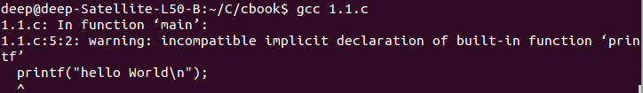
- Leaving out int or void or both
The program compiles and runs without any warning. We know that spaces and indentation is not important, so we can strip them out.
- The smallest program that compiles with warning, but executes is this.
main(){printf("hello,world\n");}
4. Any part of the string “hello,worldn” can be left out without any error, just the program output will be different.
- Leaving any other part the program will now result in compilation error.
For e.g. After removing ; in the above program, we got the compilation error.
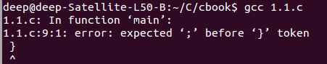

2.Experiment to find out what happens when prints 's argument string contains
\c, where c is some character not listed above.

Ans:-It run with compile warning.
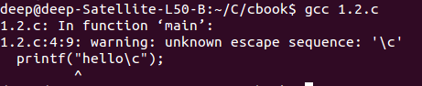

Output:-helloc

3.Modify the temperature conversion program to print a heading above the table.
Code:-
#include<stdio.h>
main()
{
int cel=0,fer;
printf("emter tempreture");
scanf("%d",&cel);
while(cel<=300)
{
fer= (1.8 * cel) + 32;
printf("%d %d\n",cel,fer);
cel=cel+20;

}}
o/p:-

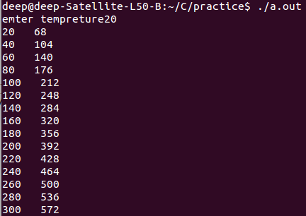

4.Write a program to print the corresponding Celsius to Fahrenheit table.
#include<stdio.h>
main()
{
int cel=0,fer;
printf("emter tempreture");
scanf("%d",&cel);
while(cel<=300)
{
fer= (1.8 * cel) + 32;
printf("%d %d\n",cel,fer);
cel=cel+20;

}}
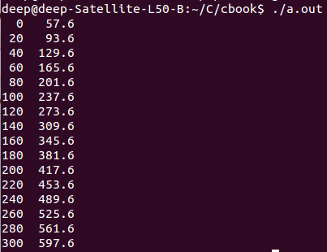
}
}

.
5.Modify the temperature conversion program to print the table in reverse order,
that is, from 300 degrees to 0.

#include<stdio.h>
main()
{
int cel,fer;
printf("emter tempreture");
scanf("%d",&cel);
while(cel>=0)
{
fer= (1.8 * cel) + 32;
printf("%d %d\n",cel,fer);
cel=cel-20;

}}

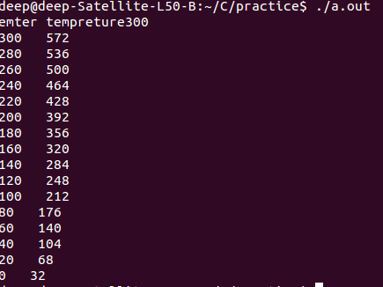

6.Verify that the expression getchar() != EOF is 0 or 1.
#include <stdio.h>

main()
{
int c;

//while ((c = getchar()) != EOF)
//putchar(c);
printf("%d\n",( c = getchar()) != EOF);
}
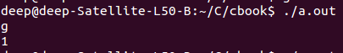

7.
#include "stdio.h"
int main(int argc, char const *argv[])
{
printf("%c\n", EOF);
return 0;
}

8.
#include <stdio.h>
/* count lines in input */
main()
{
int c, nl=0,t=0,b=0;
nl = 0;
printf("write z to exit\n");
while ((c = getchar()) != 'z')
if (c == '\n')
++nl;
else if (c=='\t')
{
t++;
/* code */
}
else if(c==' ')
{
b++;
}
printf("blank:%d\t newline:%d\t tab:%d\n", b,nl,t);
}
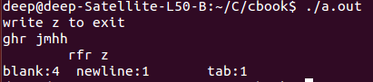

9.
#include <stdio.h>
/* count lines in input */
main()
{
int c, nl=0,t=0,b=0,i=0;
char cc[100];
nl = 0;
printf("write z to exit\n");
while ((c = getchar()) != 'z')
{
cc[i]=c;
if (c == '\n' ||c=='\t')
{
cc[i]=' ';
}
else
{
cc[i]=c;
}
i++;
}
printf("%s", cc);

}
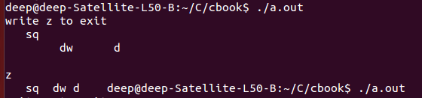
10.
#include <stdio.h>
/* count lines in input */
main()
{
int c, nl=0,t=0,b=0,i=0;
char cc[100];
nl = 0;
printf("write z to exit\n");
while ((c = getchar()) != 'z')
{
cc[i]=c;
if (c == '\n' ||c=='\t')
{
cc[i]=' ';
}
else
{
cc[i]=c;
}
i++;
}
printf("%s", cc);

}
11
Testing the word count program involves, giving three kinds of inputs.
- Valid Inputs.
- Boundary Condition Inputs.
- Invalid Inputs.
For Valid Inputs, it could be any stream of space separate text. It has valid space, newline and tab characters. For Boundary conditions, a file entirely consisting of n, or a file entirely consisting of t character or a empty file.
For invalid Inputs, an unclosed file which does not have EOF, which is tricky to provide can be give

12.
#include<stdio.h>

int main() {
char c;
scanf("%c",&c);
while (c != EOF) {
if (c == ' ') {
printf("\n");
}
else {
printf("%c", c);
}
scanf("%c",&c);
}
}
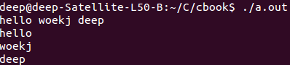

13.
#include<stdio.h>

int main(void)
{
char c;
scanf("%c",&c);
while(c != EOF)
{

if( c == ' ' || c == '\n' || c == '\t')
printf("\n");
else
printf("*");
scanf("%c",&c);
}
return 0;
}
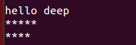

14)
#include<stdio.h>
int main()
{
int i,j;
char c[100];
int character[128];
for(i=0;i<128;++i)
character[i] = 0;
scanf("%s",&c);
i=0;
while(c[i]!=EOF)
{
i++;
character[c[i]]=character[c[i]]+1;
}
for(i=0;i<128;++i)
{
printf("%d", i);
for(j=0;j<character[i];++j)
printf("*");
printf("\n");
}
return 0;
}
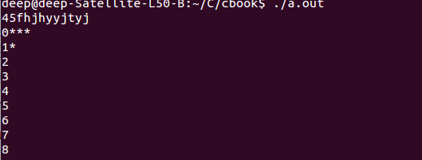
15)
#include <stdio.h>
void conversion(float fahr,float upper,float celsius,float step)
{
while (fahr <= upper) {
celsius = (5.0/9.0) * (fahr-32.0);
printf("%3.0f \t\t%6.1f\n", fahr, celsius);
fahr = fahr + step;
}
}
main()
{
float fahr, celsius;
float lower, upper, step;
lower = 0;
upper = 300;
step = 20;

printf("Fahrenheit\t Celsius\n");
fahr = lower;
conversion(fahr,upper,celsius,step);

}
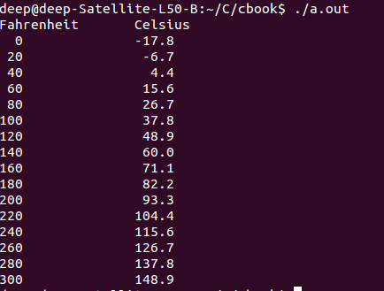

16)
#include <stdio.h>
#define MAXLINE 1000
char longest[MAXLINE];

int getline(char line[], int maxline);
void copy(char to[], char from[]);

int main()
{
int len;

int max;
char line[MAXLINE];

max = 0;
while ((len = getline(line, MAXLINE)) > 1)
{
if (len > max) {
max = len;
copy(longest, line);
}
}
if (max > 0)
printf("string:%s\nlength:%d\n", longest,max);
return 0;
}

int getline(char s[],int lim)
{
int c, i;
for (i=0; i < lim-1 && (c=getchar())!=EOF && c!='\n'; ++i)
s[i] = c;
if (c == '\n') {
s[i] = c;
++i;
}
s[i] = '\0';
return i;
}

void copy(char to[], char from[])
{
int i;
i = 0;
while ((longest[i] = from[i]) != '\0')
++i;
}
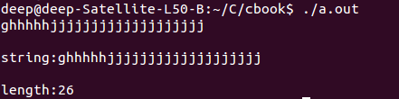

17)
#include <stdio.h>
#define MAXLINE 1000
char longest[MAXLINE];

int getline(char line[], int maxline);
void copy(char to[], char from[]);

int main()
{
int len;

int max;
char line[MAXLINE];

max = 0;
while ((len = getline(line, MAXLINE)) > 1)
{

}
if (max > 0)
//printf("string:%s\nlength:%d\n", longest,max);
return 0;
}

int getline(char s[],int lim)
{
int c, i;
for (i=0; i < lim-1 && (c=getchar())!=EOF && c!='\n'; ++i)
s[i] = c;
if (c == '\n') {
s[i] = c;
++i;
}
s[i] = '\0';
if (i>80)
{
printf("\nstring contain more than 80 char:\n\n%s\n", s);
}
return i;

}
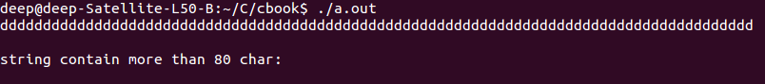
18)
#include <stdio.h>
#define MAXLINE 10000

char line[MAXLINE+1];
int getline1(void);

int main(void)
{
extern char line[];
int len, head, tail, inn;
while((len=getline1()) > 0) {
for(head = 0; line[head] == ' ' ||
line[head] == '\t'; head++);
for(tail = len; line[tail] == ' ' ||
line[tail] == '\t' ||
line[tail] == '\n' ||
line[tail] == '\0';tail--);
if(tail - head >= 0){
for(inn = head; inn <= tail; inn++)
putchar(line[inn]);
putchar('\n');
putchar('\0');
}
}
return 0;
}

int getline1(void)
{
extern char line[];
int c, i;
for(i = 0; i < MAXLINE-1 && (c=getchar())
!= EOF && c != '\n'; ++i) line[i] = c;
if (c == '\n') {
line[i] = c;
++i;
}
line[i] = '\0';
return i;
}
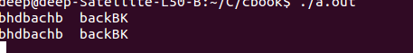

19)
#include <stdio.h>
char r[100];
void reverse(char *c)
{
//printf("%s\n",c );
int i=0,j=0;
for (i = 0; c[i]!='\0'; ++i)
{
j++;
}
for (i = 0;i<j ; ++i)
{
r[i]=c[j-(i+1)];
}
r[i]='\0';
printf("%s\n", r);
}
int main()
{
char c[100];
while(1){
printf("enter string:\n");
scanf("%s",c);
reverse(c);}
//printf("%s\n",c );}
return 0;
}
20)

#include<stdio.h>
#define TABINC 8

int main(void)
{
int nb,pos,c;

nb = 0;
pos = 1;

while((c=getchar())!=EOF)
{
if( c == '\t')
{
nb = TABINC - (( pos - 1) % TABINC);

while( nb > 0)
{
putchar(' ');
++pos;
--nb;
}
}
else if( c == '\n')
{
putchar(c);
pos = 1;
}
else
{
putchar(c);
++pos;
}
}

return 0;
}
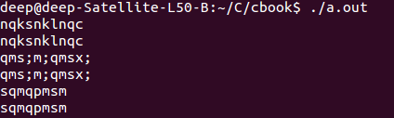

21)

#include<stdio.h>
#define TABINC 8

int main(void)
{
int nb,pos,c;

nb = 0;
pos = 1;
char a[1000];
int i=0,count=0;
while((c=getchar())!='0')
{
if( c == '\t')
{
nb = TABINC - (( pos - 1) % TABINC);

//while( nb > 0)
{
//putchar(' ');
a[i]=' ';
i++;
//++pos;
//--nb;
}
}
else if( c == '\n')
{
//putchar(c);
a[i]='\n';
i++;
pos = 1;
}
else
{
//putchar(c);
a[i]=c;
i++;

++pos;
}

}
a[i]='\0';
count=i;
//printf("%s\n",a );
for (i = 0; i < count; ++i)
{
if(a[i]==' '&&a[i+1]==' ')
{

i++;
int j=i;
while(a[j]==' ')
{
for (int k = j; k < count; ++k)
{
/* code */
a[k]=a[k+1];
}

//j++;
count--;
}

}
if(a[i]=='\n'&&a[i+1]=='\n')
{

i++;
int j=i;
while(a[j]=='\n')
{
for (int k = j; k < count; ++k)
{
/* code */
a[k]=a[k+1];
}

//j++;
count--;
}

}
}
printf("\nstring:\n%s\n",a );
return 0;
}
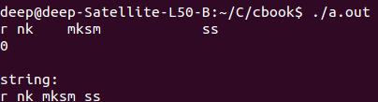

22)

#include<stdio.h>
#define TABINC 8

int main(void)
{
int nb,pos,c;

nb = 0;
pos = 1;
char a[1000];
int i=0,count=0;
while((c=getchar())!='0')
{
if( c == '\t')
{
nb = TABINC - (( pos - 1) % TABINC);

//while( nb > 0)
{
//putchar(' ');
a[i]=' ';
i++;
//++pos;
//--nb;
}
}
else if( c == '\n')
{
//putchar(c);
a[i]='\n';
i++;
pos = 1;
}
else
{
//putchar(c);
a[i]=c;
i++;

++pos;
}

}
a[i]='\0';
count=i;
//printf("%s\n",a );
for (i = 0; i < count; ++i)
{
if(a[i]==' '&&a[i+1]==' ')
{

i++;
int j=i;
while(a[j]==' ')
{
for (int k = j; k < count; ++k)
{
/* code */
a[k]=a[k+1];
}

//j++;
count--;
}

}
if(a[i]=='\n'&&a[i+1]=='\n')
{

i++;
int j=i;
while(a[j]=='\n')
{
for (int k = j; k < count; ++k)
{
/* code */
a[k]=a[k+1];
}

//j++;
count--;
}

}
}
printf("\nstring:\n%s\n",a );
count--;
//printf("%d\n",count );
//int l=20;
for (i = 0; i < count; ++i)
{
if(i!=20)
{
printf("%c",a[i] );
}
else if (i==20&&a[i]!=' ')
{
printf("%c",a[i]);
printf("-");
printf("\n");
}
else if(i==20&&a[i]==' ')
{

printf("\n");
}
}
return 0;
}
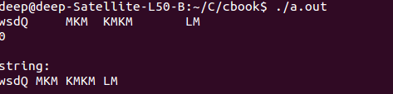

23)
#include<stdio.h>

void rcomment(int c);
void incomment(void);
void echo_quote(int c);

int main(void)
{
int c,d;

printf(" To Check /* Quoted String */ \n");

while((c=getchar())!=EOF)
rcomment(c);

return 0;
}

void rcomment(int c)
{
int d;
if( c == '/')
{
if((d=getchar())=='*')
incomment();
else if( d == '/')
{
putchar(c);
rcomment(d);
}
else
{
putchar(c);
putchar(d);
}
}
else if( c == '\''|| c == '"')
echo_quote(c);
else
putchar(c);
}

void incomment()
{
int c,d;

c = getchar();
d = getchar();

while(c!='*' || d !='/')
{
c =d;
d = getchar();
}
}

void echo_quote(int c)
{
int d;

putchar(c);

while((d=getchar())!=c)
{
putchar(d);

if(d = '\\')
putchar(getchar());
}
putchar(d);
}
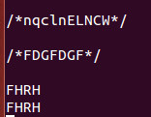

24)
#include<stdio.h>

int brace,brack,paren;

void incomment();
void inquote(int c);
void search(int c);

int main(void)
{
int c;

extern int brace,brack,paren;

while((c=getchar())!=EOF)
if( c == '/')
if((c=getchar())== '*')
incomment();
else
search(c);
else if( c == '\'' || c == '"')
inquote(c);
else
search(c);

if( brace < 0)
{
printf("Unmatched Braces\n");
brace = 0;
}
else if( brack < 0)
{
printf("Unmatched brackets\n");
brack = 0;
}
else if( paren < 0)
{
printf("Unmatched parenthesis\n");
paren = 0;
}

if(brace > 0)
printf("Unmatched braces\n");
else if(brack > 0)
printf("Unmatched brackets\n");
else if(paren > 0)
printf("Unmatched parenthesis\n");

return 0;
}

void incomment()
{
int c,d;

c = getchar();
d = getchar();

while(c != '*' || d != '/')
{
c = d;
d = getchar();
}
}

void inquote(int c)
{
int d;

putchar(c);

while((d=getchar())!=c)
if( d == '\\')
getchar();
}

void search(int c)
{
extern int brace,brack,paren;

if ( c == '{')
--brace;
else if ( c == '}')
++brace;
else if( c == '(')
--brack;
else if( c == ')')
++brack;
else if( c == '[')
--paren;
else if( c == ']')
++paren;
}
